Languages used:

Platform – Web

1. JavaScript: Used for Exam Platform and Intelligent Agent
2. PHP: Used for The server side Functionalities of the Entire System.
3. MYSQL: Used for the Database Design and Query.
4. Python: Dataset Preparation, Preprocessing and Algorithm Evaluation
5. HTML/CSS: For the User Interface Design.

Development Environment / Tools

1. Visual Studio Code: Used for Writing the Entire Codebase of the Web Platform (HTML/CSS, PHP and JavaScript)
2. JupyterNotebook: Used for Dataset Preparation, Preprocessing and Algorithm Evaluation.
3. XAMPP: XAMPP serves as the host the entire platform on a local host.

### ****Setting up Development Environment on Windows****

### *****How to setup Visual Studio Code on Windows*****

Firstly, download the Visual Studio Code installer for Windows. Once it is downloaded, run the installer (VSCodeUserSetup-{version}.exe). It will only take a minute.

[](https://www.toolsqa.com/wp-content/uploads/2020/04/Windows_Download.gif)

 Secondly, accept the agreement and click on next.

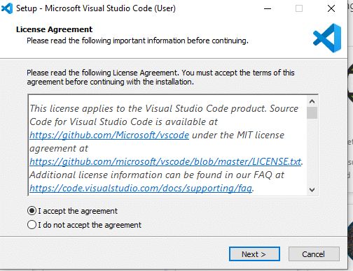

Thirdly, click on “***create a desktop icon***” so that it can be accessed from desktop and click on Next.

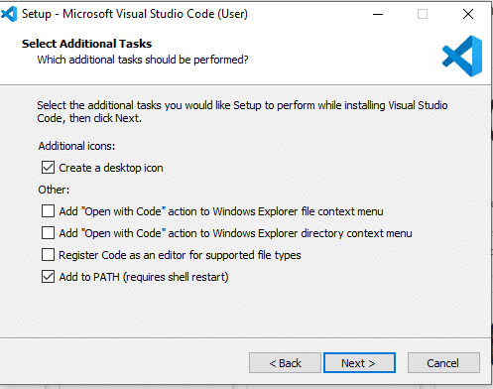

After that, click on the install button.

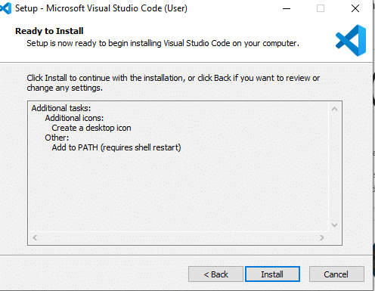

Finally, after installation completes, click on the finish button, and the visual studio code will get open.

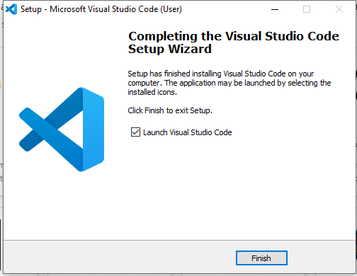

By default, VS Code installs under C:\users\{username}\AppData\Local\Programs\Microsoft VS Code.

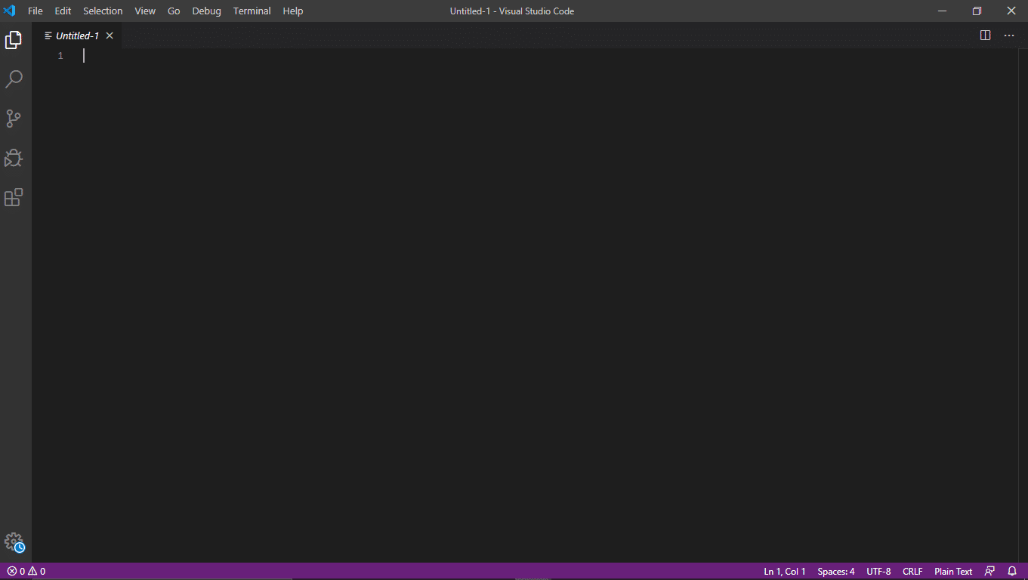

After the successful installation, let’s move to the next section to understand the various components of the User Interface of Visual Studio Code Editor. Visual Studio Code is a code editor at its core. Like many other code editors, VS Code adopts a standard user interface and layout of an explorer on the left, showing all of the files and folders you have access to. Additionally, it has an editor on the right, showing the content of the files you have opened. Below are a few of the most critical components the VSCode editor:

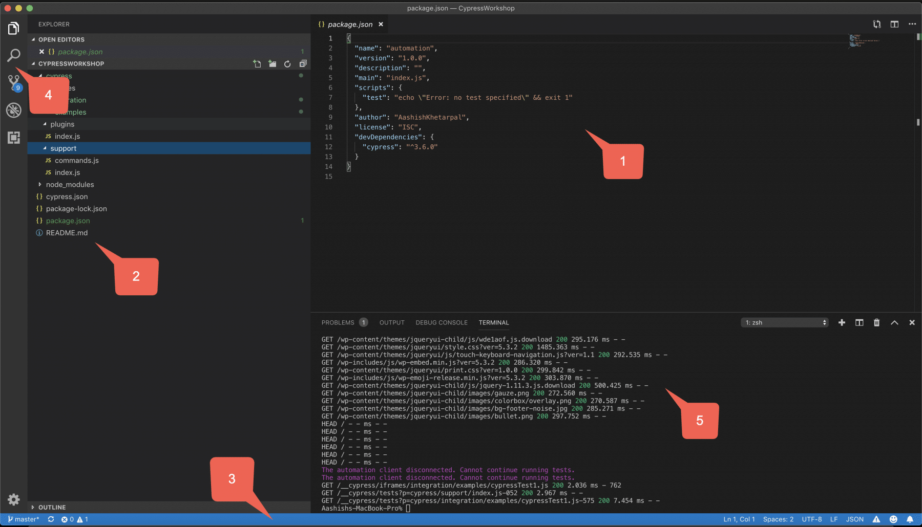

VS Code comes with a straight-forward and intuitive layout that maximizes the space provided for the editor while leaving ample room to browse. Additionally, it allows access to the full context of your folder or project. The UI is divided into five areas, as highlighted in the above image.

1. ***Editor*** – It is the main area to edit your files. You can open as many editors as possible side by side vertically and horizontally.
2. ***Sidebar*** – Contains different views like the Explorer to assist you while working on your project.
3. ***Status Bar*** – It contains the information about the opened project and the files you edit.
4. ***Activity Bar*** – It is located on the far left-hand side. It lets you switch between views and gives you additional context-specific indicators, like the number of outgoing changes when Git is enabled.
5. ***Panels*** – It displays different panels below the editor region for output or debug information, errors, and warnings, or an integrated terminal. Additionally, the panel can also move to the right for more vertical space.

# **How to install Jupiter Notebook in Windows?**

Jupyter Notebook is an open-source web application that allows you to create and share documents that contain live code, equations, visualizations, and narrative text. Uses include data cleaning and transformation, numerical simulation, statistical modeling, data visualization, machine learning, and much more.

### Installing Jupyter Notebook using Anaconda:

Anaconda is an open-source software that contains Jupyter, spyder, etc that are used for large data processing, data analytics, heavy scientific computing. Anaconda works for R and python programming language. Spyder(sub-application of Anaconda) is used for python. Opencv for python will work in spyder. Package versions are managed by the package management system called conda.

To install Jupyter using Anaconda, just go through the following instructions:

* **Launch Anaconda Navigator:**  
  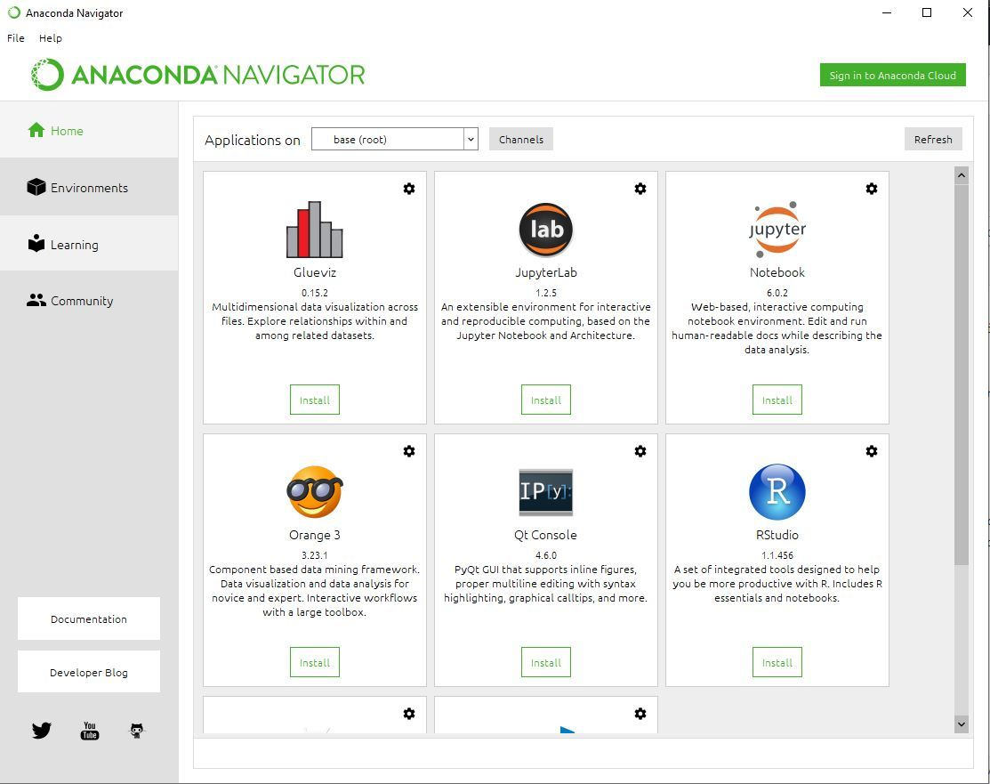
* **Click on the Install Jupyter Notebook Button:**  
  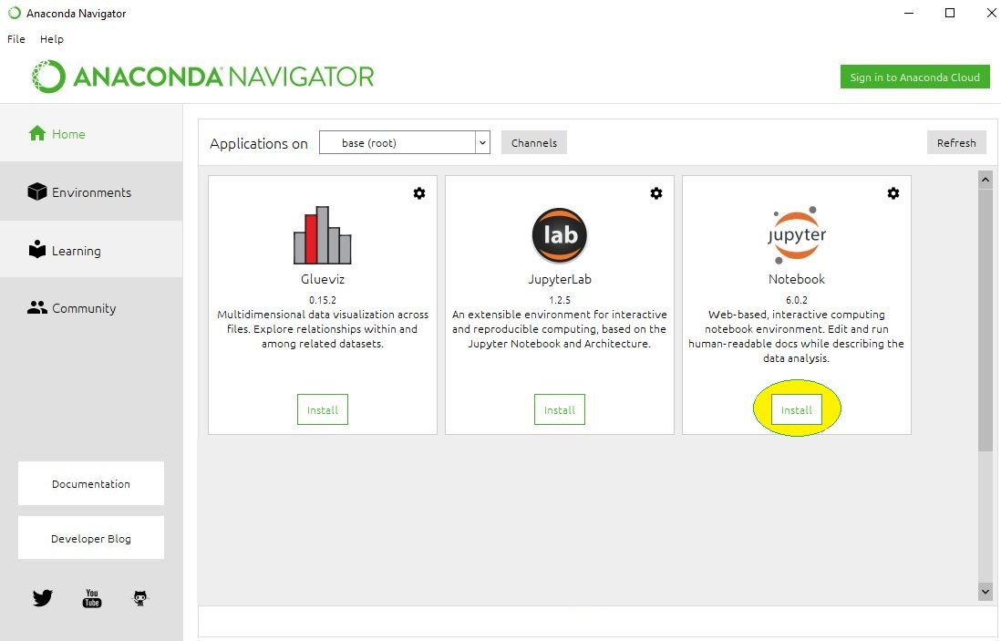
* **Beginning the Installation:**  
  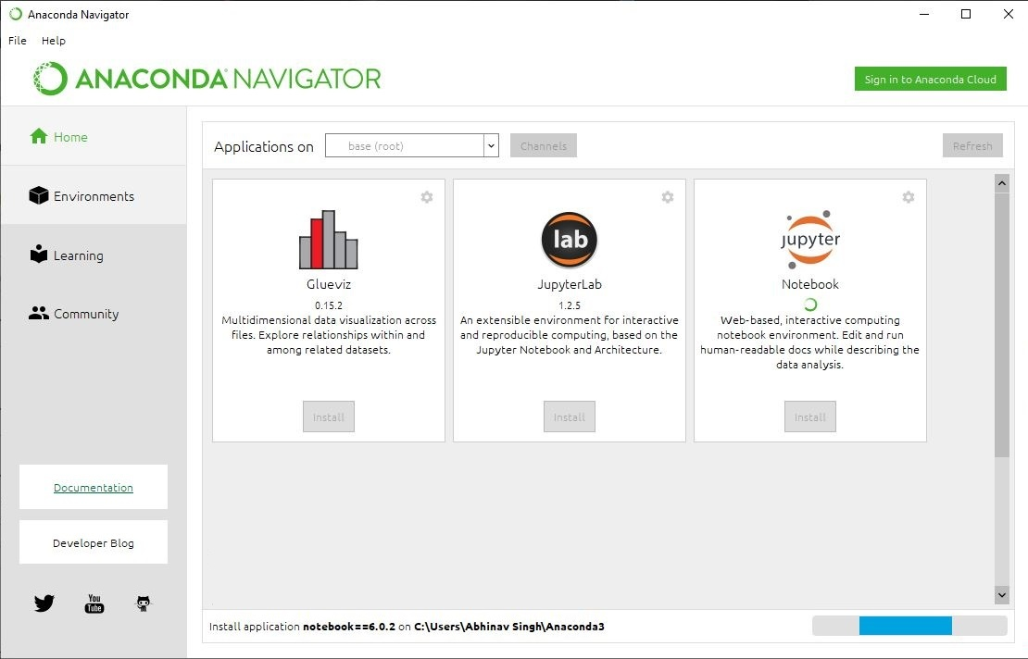
* **Loading Packages:**  
  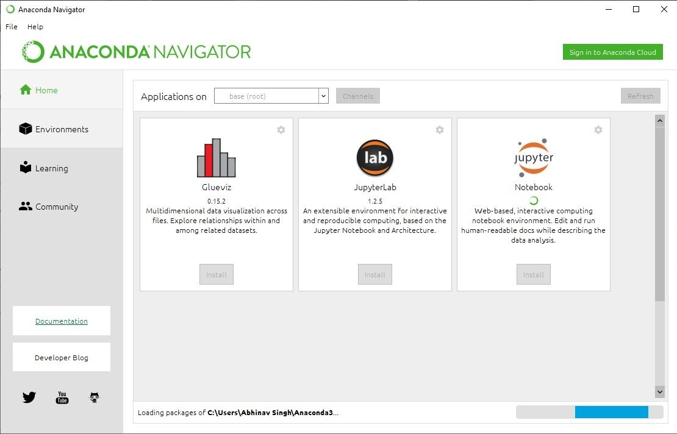
* **Finished Installation:**  
  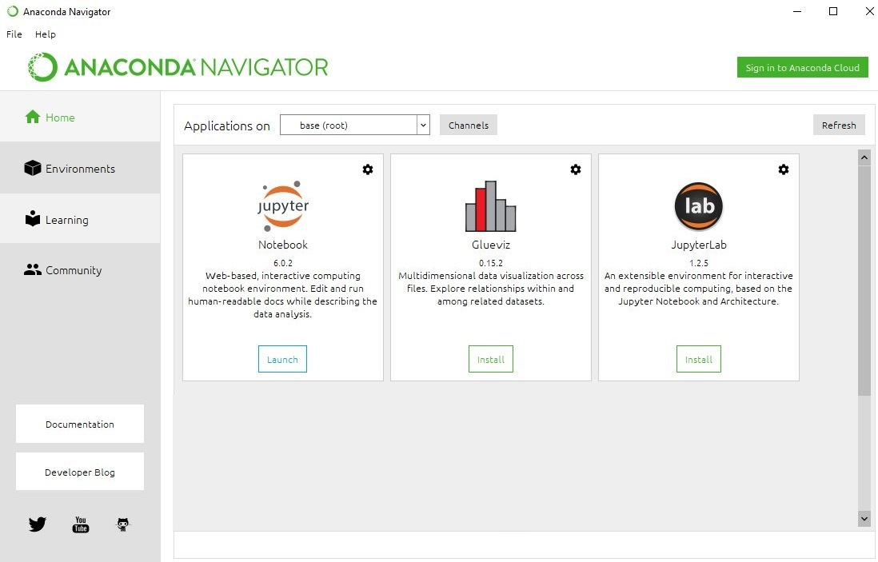

**Launching Jupyter:**  
